Stem cells enable personalised treatment for bleeding disorder

05 April 2013
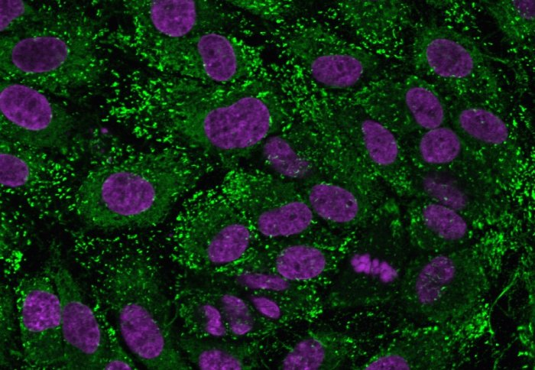
Scientists have shed light on a common bleeding disorder by growing and analysing patients' stem cells to discover the cause of their disease.
The technique may enable doctors to prescribe more effective treatments according to the defects identified in patients' cells.
In future, this approach could go much further: these same cells could be grown, manipulated, and applied as treatments for diseases of the heart, blood and circulation, including heart attacks and haemophilia.
The study focused on von Willebrand disease (vWD), which is estimated to affect 1 in 100 people and can cause excessive, sometimes life-threatening bleeding. vWD is caused by a deficiency of von Willebrand factor (vWF), a blood component involved in making blood clot. vWF is produced by endothelial cells, which line the inside of every blood vessel in our body. Unfortunately, they are difficult to study because taking biopsies from patients is invasive and unpleasant.
A group led by Dr Anna Randi at the National Heart and Lung Institute,Imperial College London used a new approach to investigate the disease. Dr Richard Starke, a British Heart Foundation Intermediate Fellow and lead author of the study, took routine blood samples from eight patients with vWD, extracted stem cells called endothelial progenitor cells, and grew them in the lab to yield large numbers of endothelial cells.
By testing these cells, they were able to analyse each patient’s disease in unprecedented detail. In some patients, the scientists found new types of defect, which may enable them to recommend improved treatments. Professor Mike Laffan, a collaborator in the study and in charge of patients with VWD at Hammersmith Hospital in West London, is looking to apply these findings to reduce severe bleeding in these patients.
Dr Randi believes that endothelial progenitor cells could become an invaluable resource for testing new drugs for vWD and other diseases. “We will be able to test the effects of a range of compounds in the patients’ own cells, before giving the drugs to the patients themselves,” she said.
This approach could have impact far beyond vWD. Endothelial cells derived from blood could also be isolated and reinjected into someone recovering from a heart attack, to help them grow new blood vessels and repair the injured heart tissue. Dr Starke says this approach avoids the main problem with transplant therapies, in which the immune system tries to destroy the foreign material. “The patients would receive their own cells, so they wouldn’t face the problems of rejection,” he said.
Work is well underway towards achieving this goal, but blood-derived endothelial cells are only now being explored. “There are already many studies where patients have been injected with stem cells to see whether damage to the heart could be repaired, and there are some promising results,” says Dr Randi. "The door is open to such treatments, and our studies are a step towards identifying the right cells to use."
The group’s previous research has already thrown up pointers for potential new treatments. Aside from producing vWF to form clots, endothelial cells are responsible for forming new blood vessels. In their last paper, the group showed that vWF is actually needed to build healthy blood vessels. Some patients with vWD suffer severe bleeding from the gut because defects in vWF cause their blood vessels to develop abnormally. “There are drugs already being used in other diseases which target abnormal blood vessel, that could be useful to stop bleeding in some vWD patients,” says Randi. "Nobody would have thought of using them to treat vWD, but by testing them on the patient’s own endothelial cells , in the laboratory, we can find out if these drugs work before giving them to the patient."
Scientists are now interested in the possibility of using endothelial cells as a treatment in themselves. For instance, haemophilia, the hereditary bleeding disorder which affected Queen Victoria’s family, might one day be treated by taking these cells from a patient and replacing the gene that causes the disease, then putting them back into the patient.
Funding for the study came from the British Heart Foundation, theMedical Research Council and the National Institute for Health Research Imperial Biomedical Research Centre.

REFERENCE
RD Starke et al. ‘Cellular and molecular basis of Von Willebrand Disease: studies on blood outgrowth endothelial cells.’ Blood April 4, 2013 vol. 121 no. 14 2773-2784 doi: 10.1182/blood-2012-06-435727

